Computer Shop System

Business Use-Case Specification: Manage Category

Version 1.0

Revision History

|  |  |  |  |
| --- | --- | --- | --- |
| **Date** | **Version** | **Description** | **Author** |
| 13/12/2019 | 1.0 | details | Phung Minh Nguyet |
|  |  |  |  |
|  |  |  |  |
|  |  |  |  |

Table of Contents

1. Introduction 4

1.1 Purpose 4

1.2 Scope 4

1.3 Definitions, Acronyms, and Abbreviations 4

1.4 References 4

1.5 Overview 4

2. Business Use-Case Name 4

2.1 Brief Description 4

3. Goals 4

4. Performance Goals 4

4.1 <name of performance goal> 5

5. Workflow 5

5.1 Basic Workflow 5

5.1.1 <name of workflow step> 5

5.2 Alternative Workflows: Still achieve success but in different way 5

5.2.1 <name of workflow step> 5

6. Risk 5

7. Possibilities 5

8. Process Owner 5

9. Special Requirements 5

9.1 <Name of Special Requirement 1> 5

9.2 <Name of Special Requirement 2> 5

10. Extension Points 6

10.1 <Name of Extension Point> 6

Business Use-Case Specification: Manage Category

# Introduction

The Business Use-case Specification will show you an overview about our product management system which our company will build in the future. This will be an instructions for users using our system.

In this document, we will provide you basic knowledge about our system we will deploy in the future. It describes in details about interactions between admin of system and users. By what we show you, you will have a thorough insights of what the system works and how to use it.

## Purpose

The purpose of this business use-case is to show how to manage category of the computer shop when manager deal with problems happens related category without the category management system

## Scope

The use-case is for our admin of our system. They make sure that they will use and work for our system and cooperate to develop successfully.

## Definitions, Acronyms, and Abbreviations

Manager: admin

## References

TBD.

## Overview

The rest of the Business Use-case Specification contains goal, risk, process owner and special requirement.

# Business Use-Case Name

## Brief Description

The use-case is that “Manage category managers” which means the managers have to deal with all problems related to category of the online shop.

# Goals

# In this use-case, managers have 3 main tasks: create a new category, update the category and remove the category

# Performance Goals

## Create category

When the shop want to add more category, the manager will create a new category that depends on its information.

**4.2 Update category**

When manager has category, but they have some problems related to that so the manager can update the information inside the category .

**4.3 Delete category**

If the category have some problems such as out of product , their category need to be removed

# Workflow

## 5.1 Basic Workflow

When the shop runs out of computers in this category or it does not have enough computer to sell, the owner request more and more computers in this category. The system receives information of the computers and delivers those to the shop. The owner receives the information of the computers. The system received the information save to the database. The business case ends.

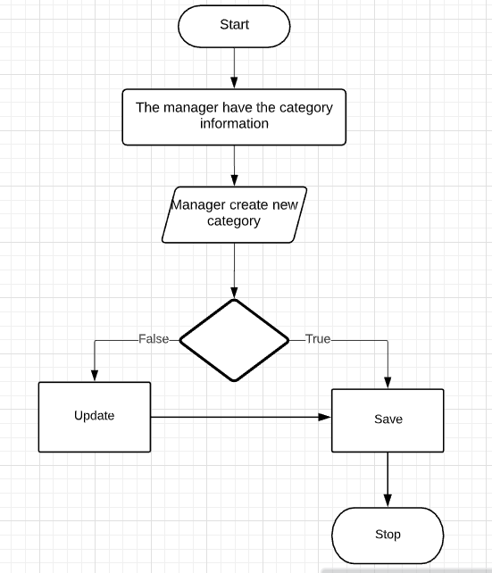

# Risk

No special.

# Possibilities

No special.

# Process Owner

The process owner if this usecase is the administrator or can be called manager of the computer shop who deal with the situation.

# Special Requirements

No special.

# Extension Points

## <No extension Point>